 | 
Cross Product Spreads – Phase I System Specifications Document


Version: 0.7 (Draft)
Date: 04th October 2007

Cognizant Technology Solutions
www.cognizant.com
The information contained in this document is confidential and intended for the named recipient only. This information is joint property of “CBOE” and “Cognizant Technology Solutions”, and copying or disclosure by any other person is strictly prohibited. If you have received this documentation in error, please notify sender immediately.
Table of Contents
1 Introduction 7
1.1 Background 7
1.2 Purpose & Scope of this document 7
1.3 Intended Audience 7
1.4 Document Structure 8
1.5 Assumptions 8
1.6 Abbreviations and Acronyms 8
2 Business Strategy 10
2.1 Business Overview 10
2.2 Key Business Drivers 10
2.3 Business Goals 10
3 System Specifications 11
3.1 Cross Product Spread Order 11
3.1.1 Cross Product Spread Order - Definition 11
3.2 CPS Business Rules Summary 12
3.2.1 CPS Trading and Routing Rules 13
3.3 CPS Product – Trading Process 13
3.3.1 Dissemination of CPS Product Data 13
3.3.2 CPS Product Creation 14
3.3.2.1 Create a CPS Product in the CBOEdirect Trader GUI 15
3.3.3 CPS Product States and Order Types Accepted 19
3.3.3.1 CPS Product States 19
3.3.3.2 CPS Order Types Accepted 20
3.3.4 CPS Order Entry 21
3.3.4.1 CPS Leg Details 21
3.3.4.2 Same or Opposite 22
3.3.5 CPS Order Book 22
3.3.6 CPS Trading – High Level Process Flow 23
3.3.6.1 System View 23
3.3.6.2 Stage 1 – Initial Order Entry to OHS 24
3.3.6.3 Stage 2 – Order Routing from OHS to TPF 25
3.3.6.4 Stage 3 –Order Routing from TPF to OHS and OHS to ORD 25
3.3.6.5 Stage 4 – Order validation by ORD 27
3.3.6.6 Stage 5 – Order Acceptance and Execution in CBOEdirect 28
3.3.7 Matrix of Validations 28
3.3.8 CPS Order Execution in CBOEdirect– Processing Flow 29
3.3.8.1 Basic Flow 29
3.3.8.2 Alternative Flows 31
3.3.8.3 Business Rules 32
3.3.9 CPS Order Locking 32
3.3.9.1 Basic Flow 32
3.3.10 CPS Order Trading of TPF/PAR routed orders 34
3.3.11 CPS Post-trade Activities 34
3.3.11.1 Reporting of CPSB – CPSB Trade 34
3.3.11.2 Reporting of CPS Leg Market Trading 35
3.3.11.3 Trade Report 35
3.3.11.4 Fill Report Changes 35
3.3.11.5 Trade Report Changes 36
3.4 End of Day Process 38
3.4.1 Expiring CPS Orders 38
3.4.2 Trade Busts 38
3.4.3 Deletion of CPS Products 38
3.5 CBOEdirect GUI Requirements for CPSs 39
3.5.1.1 Clearing Firm 39
3.5.1.2 Order Information 44
3.5.1.3 New Error Messages 45
3.6 Derived Spread Market 45
3.6.1.1 Calculation of the Derived Spread Market (DSM) 45
3.6.1.2 Using NBBO for DSM Calculations 46
3.7 COA for CPS Orders 46
3.7.1 COA Configurations 46
3.7.1.1 Price Protect Percentage related changes 46
3.7.2 Order Handling Instructions from TPF 47
3.7.3 Order Handling Instructions from PAR 47
3.7.4 Receiving a CPS Order routed from TPF/COMPASS 47
3.7.4.1 Execution Price 47
3.7.4.2 Maximum Execution Volume 47
3.7.5 COA Process 47
3.7.5.1 Pre-Auction Criteria 47
3.7.5.2 Auction Process 48
3.7.5.3 Auction Allocation 49
3.7.5.4 Penny Better Execution 50
3.8 Order Routing/Handling and Instruction Codes 51
4 Non-functional Specifications 51
4.1 Performance Benchmarks 51
4.1.1 Quote Specs for Option Leg Market 52
4.1.2 Order Specs for Option Leg Market 52
4.1.3 Quote Specs for Stock Leg Market 52
4.1.4 Order Specs for Stock Leg Market 52
4.2 Adhoc Reports 52
4.3 Database Changes 52
5 Key Assumptions, Constraints, and Dependencies 53
6 Open Items and Issues 53
7 Appendix 54
7.1 Appendix A: Glossary 54
7.2 Appendix B: Examples for Penny Better Execution 56
7.2.1 Example 1 56
7.2.2 Example 2 57
8 References 59

Document Version History

Sr. No | Date | Version | Created / Modified By | Description
1 | 10-Apr-07 | 0.0 | Raghuram T | Draft base template for the specifications
2 | 07-May-07 | 0.1 | Raghuram T | First Draft for internal team review
3 | 14-May-07 | 0.2 | Raghuram T | Updated with review comments
4 | 20-Jun-07 | 0.3 | Raghuram T | Updated with Iteration-3 related functionalities and other review comments
5 | 25-Jul-07 | 0.4 | Raghuram T | - Added ‘Using NBBO for DSM Calculations’ and ‘Fill Report Changes’ sections  - Other Minor updates for the final review
6 | 23-Aug-07 | 0.5 | Raghuram T | - Added ‘Trade Report Changes’ sections  - Minor updates in COA processing
7 | 20-Sep-07 | 0.6 | Raghuram T | - Updated the following sections:  - 3.6.1.2 Using NBBO for DSM Calculations  - 3.7.5.2.5.3 Pre-mature Expiration w.r.t. CPS product  - 3.7.5.2.4 Joining an Existing Auction  - Added a rule in 3.2.1 CPS Trading and Routing Rules  - Added the following sections  - 3.7.1.1 Price Protect Percentage related changes  - 3.7.5.3.1 Fills for joined orders  - 3.7.5.3.2 Fills with AON orders in Leg Markets
8 | 04-Oct-07 | 0.7 | Raghuram T | - Added the following sections  - 3.7.5.4 Penny Better Execution  - 7.2 Appendix B: Examples for Penny Better Execution

Document Review History

Version | Date | Reviewed By | Comments
0.1 | 07-May-07 | Steven Sinclair  Dev. Team | Reviewed and discussed in person.  Comments mailed to Raghuram T.
0.3 | 19-Jun-07 | Steven Sinclair | Reviewed and discussed in person.
0.7

Document Approval History

Version | Date | Approved By | Comments
 |  | Eileen Smith
 |  | Mike Trees
 |  | Anthony Montesano
0.3 | 19-Jun-07 | Steven Sinclair

Introduction

Background
The Chicago Board Options Exchange (CBOE), is one of the world's largest options exchanges with an annual trade of over 450 million options contracts, covering more than 1700 companies, 50 stock indexes, and 50 Exchange-Traded Funds (ETFs). But currently the execution of Cross Product Spread (CPS) products (i.e. complex spread orders with a stock or index leg) is mostly handled manually. And also this process is cumbersome and time consuming and at times results in a difficulty in putting up the stock print at the appropriate price. Hence CBOE decided to modify its systems to automate the trading of Cross Product Spread (CPS) products.

As competition continues to intensify, not only among existing options exchanges, but also from the looming threat of new market entrants, CBOE is poised to remain the industry leader. CBOE’s Hybrid Trading System has proven to be a robust and highly efficient market model and also the Exchange is regularly refining the system. In continuation of CBOE’s mission to provide unparalleled customer service, CBOE is looking at innovative investment products and cutting-edge technology.

“The CBOEdirect Trading System was designed with flexibility in mind so that adaptations can be made quickly as the dynamics of the marketplace change.”

The ‘Cross Product Spreads’ project is an initiative by CBOE to electronically execute and/or auction an entire Cross Product Spread (CPS) product.

Purpose & Scope of this document
This document details the system specifications for Phase - I implementation of the Cross Product Spreads project. This document is mainly intended to capture any changes or deviations to the current day Complex Spread Order trading but not to detail all of the As-Is existing working/flows, business rules and validations.

The main scope of implementation for Phase I of the project is:
- Cross Product Spread (CPS) orders having 2 legs (i.e. a stock leg and an option leg) only
- All legs are of the same underlying.
- The leg markets are not monitored.

Note: CPS products containing index options (i.e. for example either SPX or OEX index options with SPY) will be addressed in the later phases.

Intended Audience
This document is primarily intended for the following audience.
- Project Managers
- Product Development Team
- Testing Team

Document Structure
The table below defines the structure of this document

Section | Name | Description
1 | Introduction | Mainly contains the background, scope and purpose of this specifications document.
2 | Business Strategy | Describes the key business drivers and goals.
3 | System Requirements | Details the specifications for the CPS implementation
4 | Non-functional Requirements | Details the Non-functional specifications for the CPS implementation
5 | Assumptions, Constraints, and Dependencies | Lists the Assumptions, Constraints, and Dependencies
6 | Open Items and Issues | Lists the open items and issues (if any) along with their closure status.
7 | Appendices | Includes supplementary information like glossary
8 | References | Provides a list of the referenced source documents, and web sites

Assumptions
- Complex Order Book (COB) and Cross Product Spread Order Book (CPSB) are not used synonymously in this document. They refer to two different books governed by individually defined rules.
- ‘CBOEdirect Trading Engine’ and ‘system’ are used synonymously in this document.
- The ORD referred to in this document is w.r.t. the HyTS for CPS routing and trading is the new ‘ORD Cross Product’.
- Unless otherwise stated specifically to be different, all the functionalities for CPS products must be the same as functionalities existing currently for Option Spread products.

Abbreviations and Acronyms
Item | Description
BBO | Best Bid or Offer
BOTR | Best of The Rest
CMTA | Clearing Member Trade Agreement
COA | Complex Order Auction
COB | Complex Order Book
COPP | CBOE OPRA Participant Processor
CPS | Cross Product Spread E.g. Buy-Write, Married Put
CPSB | Cross Product Spread order Book
DSM | Derived Spread Market
EqTS | Equity Trade Server
HyTS | Hybrid Trade Server
MDS | Market Data Service
NBBO | National Best Bid or Offer
OHS | Order Handling Service in CBOEdirect
OMS | Order Maintenance Service in CBOEdirect
ORD | Order Routing Destination in CBOEdirect
ORS | Order Routing Service in TPF
QRM | Quote Risk Manager
RFP | Request For Price
RFQ | Request For Quote
TPF | Transaction Processing Facility
TSB | Top of the Spread Book
TSS | Trade Support System

Business Strategy

Business Overview
Currently CBOE accepts complex spread orders with a stock leg. But they are not executed in CBOEdirect. Instead they are routed to the trading floor (i.e. to PAR). And on the floor, they are traded in the open outcry with a manual execution required separately for the stock and option legs.

This process is cumbersome and time consuming and at times results in a difficulty in putting up the stock print at the appropriate price. Hence CBOE decided to modify its systems to automate the trading of Cross Product Spread (CPS) products.

Key Business Drivers
Currently, CBOE provides spread book functionality that automatically executes option-option spreads; auctions certain spreads; and books and monitors the legs for spreads that are away from the market.

The key purpose of this ‘Cross Product Spreads’ project is to enhance CBOE’s existing spread book functionality to include spreads across different underlying products (i.e. stock, option, index, futures). The logical next step for this functionality is to allow spreads between multiple option products i.e. options and stocks, options and futures, Options and ETFs, etc. This inter-market trading facility is so far largely untapped and could provide a significant new order flow to CBOE.

Business Goals
The main goal of the ‘Cross Product Spreads’ project is to provide spread book functionality between products on different underlying securities, different business clusters, and different sessions. For example, a spread product made of a stock leg from W_STOCK session and an option leg from W_MAIN Session.

System Specifications

Cross Product Spread Order

Cross Product Spread Order - Definition
Cross Product Spread (CPS) order is an order to Buy or Sell a stated number of Option contracts, and also Buy or Sell the same underlying Stock or Exchange-Traded Fund (ETF) share, generally, in an amount that would offset (on a one-for-one basis) the option position.

The four different CPS orders that are of relevance in this phase are:
- Married Put (or) Synthetic Long Call - An order to simultaneously Buy Stock and Buy a Put option where both have the same underlying.
E.g.: Buy 100 Shares XYZ, Buy 1 XYZ July07 50 Put
- Synthetic Call (or) Synthetic Short Call - An order to simultaneously Sell Stock and Sell a Put option where both have the same underlying.
E.g.: Sell 100 Shares XYZ, Sell 1 XYZ July07 50 Put
- Synthetic Put (or) Synthetic Long Put - An order to simultaneously Sell Stock and Buy a Call option where both have the same underlying.
E.g.: Sell 100 Shares XYZ, Buy 1 XYZ July07 50 call
- Buy-Write (or) Synthetic Short Put - An order to simultaneously Buy Stock and Sell a Call option where both have the same underlying.
E.g.: Buy 100 Shares XYZ, Sell 1 XYZ July07 50 call
The possible ‘Same’ and ‘Opposite’ pairs of the four CPS orders are as follows:

Pair# | Same | Opposite
1 | Married Put (or) Synthetic Long Call  - Buy Stock  - Buy Put | Synthetic Call (or) Synthetic Short Call  - Sell Stock  - Sell Put
2 | Synthetic Call (or) Synthetic Short Call  - Sell Stock  - Sell Put | Married Put (or) Synthetic Long Call  - Buy Stock  - Buy Put
3 | Synthetic Put (or) Synthetic Long Put  - Sell Stock  - Buy Call | Buy-Write (or) Synthetic Short Put  - Buy Stock  - Sell Call
4 | Buy-Write (or) Synthetic Short Put  - Buy Stock  - Sell Call | Synthetic Put (or) Synthetic Long Put  - Sell Stock  - Buy Call

Note: A trader must be allowed to create and trade a CPS product with any other combination of the Equity and Option legs, which is not detailed in the above table.

CPS Business Rules Summary
- The minimum increment for Bid and Ask for CPS products is 0.01.
- A CPS order with more than two legs must not be accepted and must be rejected back to the Firm. It must have 2 legs only of which one leg is option and the other leg is stock.
- A CPS order with the option leg’s underlying stock different from the stock leg in the product must not be accepted and must be rejected back to the Firm.
- A CPS order with the stock leg quantity either in odd lots (i.e. quantity less than 100) or mixed lots must not be accepted and must be routed to TPF/PAR. The stock leg quantity must always be in multiples of 100. E.g. 200, 300 etc. is allowed. But 50, 150, 225, etc. is not allowed.
- A CPS order with leg ratios other than 1:100 like 2:100 or 2:300 (i.e. x: (y * 100) where x and y are positive integers) must not be accepted and must be routed to TPF/PAR. The leg ratios (i.e. n(option) : n(stock)) must always be 1:100 ➔ 1:1.
- All CPS order books must be located within the W_MAIN session only.
- CPS orders resting in the CPS order book will not monitor the individual leg markets.
- For CPS orders resting in the CPS order book, the orders must be filled with the price-time priority.
- For an incoming CPS order, the system must attempt to trade first with the resting orders in the CPS order book followed then against the individual leg order books.
- For a CPSB-CPSB trading, the last sale must be published out to both the trade servers (i.e. EquityTS & HybridTS).
- Stock Leg validation must be done (i.e. the underlying class must be active on CBSX for the CPS to be traded).
- The following rules must be considered w.r.t. quotes.
  - NBBO must be used for DSM / DQ calculations.
  - NBBO must be used for leg market (i.e. stock and option) trading.
  - Quotes for CPS orders must not be accepted and must be rejected.
  - Quote lock and Quote trigger functionality must not be available for CPS trading.
  - RFQ must not be allowed.
  - QRM service must not be provided.
- Except for Immediate-Or-Cancel (IOC), no other contingencies must be allowed in the CPS order.
- I (In-Crowd Market) CPS orders must not be accepted and must be rejected back to the Firm.
- For CPS product state, the system must listen for the option leg product state and the option leg best book update events.
- The CPS product state must be tied directly to the state of the option leg in it. And this must be applicable in the both the following cases.
  - A CPS product with the stock leg listed on CBSX
  - A CPS product with the stock leg not listed on CBSX
  - A CPS product will manage its ON_HOLD based only on the option leg’s state and market.
- If CBSX is down then the CPS orders must not be traded.
- CBSX does not allow “trade-through” until and unless it meets some pre-defined large volume exceptions/criteria.
- CPS orders @ Market and with any contingency like IOC must be routed to TPF/PAR.
- CPS products must be allowed to be created in the W_MAIN session only.
- CPS products created with any other combination of the Equity and Option legs that are not the following products must be routed to PAR.
  - Married Put (or) Synthetic Long Call
  - Synthetic Call (or) Synthetic Short Call
  - Synthetic Put (or) Synthetic Long Put
  - Buy-Write (or) Synthetic Short Put
- The following CPS products must not be allowed to be created.
  - Option-and-Stock (with different underlying)
  - Option-and-Option (with different underlying)
  - Option-and-Futures (with same or different underlying)
  - Stock-and-Futures (with same or different underlying)

CPS Trading and Routing Rules
- A CPS order with the stock leg not listed on CBSX must not be accepted and must be routed to TPF/PAR.
- A CPS order, which is inbound from TPF must be routed back to TPF, if it is marketable (i.e. the CPS price crosses or locks with either the opposite side booked or auctioned CPS price), but the individual leg market pricing does not favor the trade to happen.
- For CPS orders inbound from PAR, only the T/A, Book, and Auction instructions must be accepted. CPS orders with any other PAR instructions must be rejected back to TPF/PAR.
  - For ‘T/A’ (Trade with All) instruction the system must not do COA but must trade against both the CPS order book and the individual leg books as well and return the remainder to PAR.
  - For ‘Book’ instruction the system must do COA and return the remainder to PAR.
  - For ‘Auction’ instruction the system must do COA and return the remainder to PAR.
- In a CPS order, the stock leg will be traded as an IOC order and there must be no linkage.
- In a CPS order, the last sale of the stock leg must be within the NBBO. If not so then the system must roll back the order execution and route the order back to TPF/PAR.
- A CPS order with the pricing specified for the individual legs is to be considered as a “Delta Neutral” strategy order, and must be routed to TPF/PAR.
- In order to avoid repeated routing of CPS orders that cannot be handled permanently by CBOEdirect like a CPS order with underlying stocks that are not listed on CBSX, CBOEdirect will provide TPF/PAR with return codes, on an order basis as to which CPSs are not eligible for COA. TPF will then set the COA eligibility flag to ‘N’ so that PAR does not enable auctions.
- CPS orders with Good-Till-Cancelled (GTC) instruction must be routed to TPF/PAR.
- CPS trades on leg markets (i.e. for W_STOCK and W_MAIN) must be executed at NBBO only.

CPS Product – Trading Process

Dissemination of CPS Product Data
At the beginning of the trading session, CBOEdirect will download CPS product data to all participants. Included in this download are product data on all CPS products that have been defined in the system. CPS product data includes the definition of the individual legs of the spread (the series ID, buy or sell, and the number of shares or contracts for each leg), and the product key, assigned by CBOEdirect, that the trader must use to enter orders for the CPS product.

An example of a CPS product is:
- Buy 100 IBM Shares
- Sell 1 IBM Jul 2007 95 Call

This Buy-Write CPS product has two legs (i.e. a stock leg and an option leg), one buying 100 shares and the other selling one Call with that same stock as the underlying. The product key would be “Buy/Write:xxxxxxxxxxxxx” followed by 13 digits that makes the key of this particular CPS product unique among all strategy products in CBOEdirect.

CPS Product Creation
CBOEdirect will allow a trader to request through the APIs (i.e. CMi and FIX) for the creation of a new CPS product as follows.
- The trader will define a CPS product providing the details like series ID, buy or sell, and the number of shares or contracts with each of the legs.
- Upon receipt of a CPS product request, CBOEdirect will determine if the particular product or its opposite already exists.
- CBOEdirect requires that only a single CPS product definition exist for the same and opposite CPS orders so that it can arrange the orders in a CPS order book and match them. Hence the system does the following.
  - If the requested CPS product currently exists, then CBOEdirect responds (i.e. displays/highlights) the existing product key, which the trader may then use to enter a spread order.
  - If the requested CPS product does not currently exist, then CBOEdirect will create a new CPS product, and send a response (i.e. display/highlight) back to the trader with the new product key.

As shown below, CBOEdirect will allow a trader to create a spread product the way one wants it, if it or its opposite side does not currently exist.

Example 1: Let us assume that one has submitted the following CPS product.
- Buy 100 IBM Shares
- Sell 1 IBM Jul 2007 95 Call

If the CPS product, as submitted, or its opposite or mirror image (i.e. Sell 100 IBM shares and Buy 1 IBM Jul 2007 95 Call) already exists, then CBOEdirect will respond with the pre-defined product key.

Example 2: Let us assume that one has submitted the following CPS product.
- Buy 300 IBM Shares
- Sell 3 IBM Jul 2007 95 Call

The system firstly reduces the quantities to the lowest possible ratio, which here will be 1:100 from 3:300. And if the CPS product, as submitted, or its opposite (i.e. Sell 100 IBM shares and Buy 1 IBM Jul 2007 95 Call) already exists, then CBOEdirect simply will respond with the pre-defined product key. In the case where it does not exist, then CBOEdirect automatically will create the new CPS product, and send a response back to the trader with the newly defined product key.

Create a CPS Product in the CBOEdirect Trader GUI

Brief Description
This use case describes the process by which a user is able to create (i.e. define and submit) a CPS product using the CBOEdirect Trader GUI.

Actors
- Trader
- Market Maker
- Firm
- Operations / Help Desk

Preconditions
- The user is successfully logged into the CBOEdirect SBT system.
- The user has permission to access this function.
- The user has the ‘Market Display’ window open.

Basic Flow
- This use case begins after the user has added an option or strategy product class in the ‘Market Display’ window.
- The system displays series meeting the selected criteria.
- The user selects any of the displayed series.

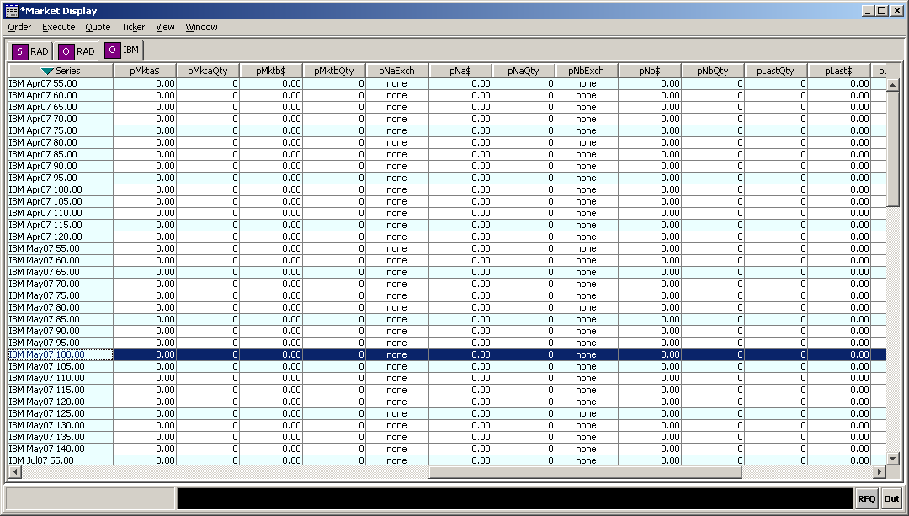

- The user clicks the ‘Order’ menu.
- The user selects ‘Spread Creation Entry’ from the following options.
  - Add New Order
  - Order Status
  - Spread Creation Entry
  - Add New Internalization Order
- The system displays the ‘Find Product’ window with the following tab options.
  - Strategy Containing Leg
  - Strategy Match
  - Strategy Assist

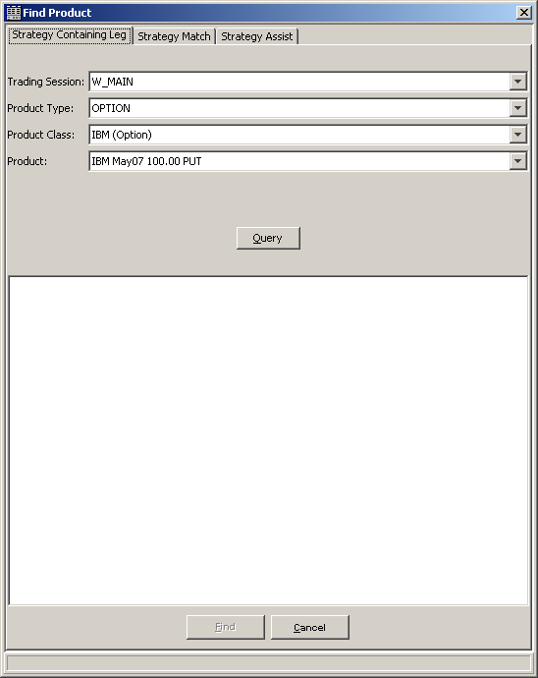

- The user clicks the ‘Strategy Match’ tab.
- To create the first leg of the CPS product, the user selects a ‘Product Type’ of his choice.
- The user selects the ‘Product Class’ of his choice.
- The user selects the ‘Product’ of his choice.
- The user inputs the ‘Quantity’ of his choice.
- The user selects the ‘BUY’ or ‘SELL’ side of his choice.
- The user clicks the ‘Add’ button from the following three options.
  - Add
  - Update
  - Delete
- The system displays the details of Leg# 1.
- To create the second leg of the CPS product, the user repeats steps 8 to 13.
- The system displays the details of Leg# 2 below Leg# 1.
- The user selects “W_MAIN” as the ‘Trading Session’.

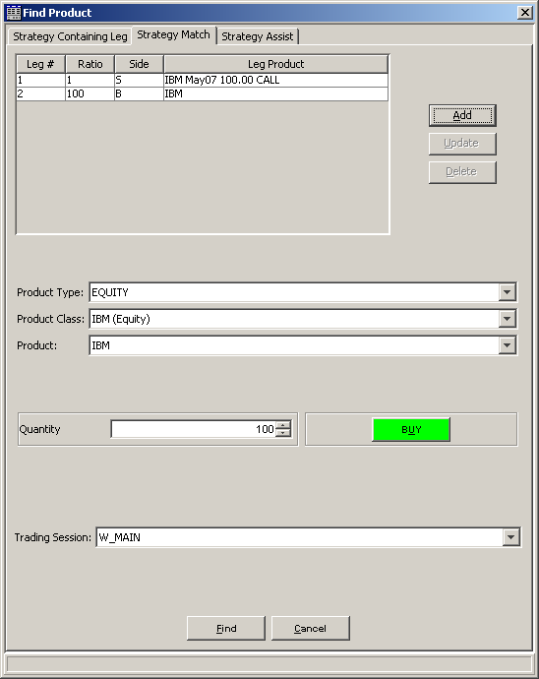

- The user clicks the ‘Find’ button.
- The system displays the created “STRATEGY” product in the Market Display window in the “STRATEGY” tab for that underlying.

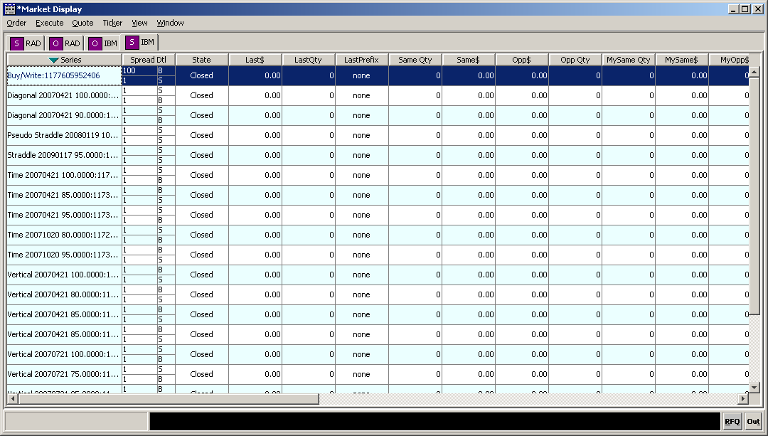

- The use case ends.

Post Conditions
- If the added CPS product does not exist then they system creates a new product.
- If the added CPS product already exists then they system just displays that existing CPS product.

Alternative Flows

Alternative Flow1 – Click Cancel
In any step of the Basic Flow, if the user clicks the ‘Cancel’ button, the system returns the user back to the ‘Market Display’ window.

Alternative Flow2 – Create a CPS product from the ‘Strategy Assist’ tab.
- Starting at Basic Flow – Step 7, the user clicks the ‘Strategy Assist’ tab.
- The user clicks the ‘Anchor Leg’ button.
- The system displays the ‘Class / Product Selection’ window.

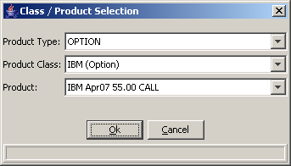

- To create the first leg of the CPS product, the user selects ‘OPTION’ as the ‘Product Type’.
- The user selects the ‘Product Class’ of his choice.
- The user selects the ‘Product’ of his choice.
- The user clicks the ‘OK’ button.
- The system returns to the ‘Strategy Assist’ tab displaying the Anchor Leg as selected above.
- The user selects ‘Buy Write’ as the ‘Strategy Type’ from the drop down list.
- The user clicks the ‘Build’ button.
- The system displays all the leg details for the CPS product where in the user can Update, Delete or Add leg information of his choice.
- The user clicks the ‘Find’ button.
- The system displays the created “STRATEGY” product in the Market Display window in the “STRATEGY” tab for that underlying.
- The use case ends.

(Note: Currently it appears that the Strategy Assist is configured to only populate by default 1 contract for each of the legs, unlike for a CPS where it is required to have 1 option contract in one leg and 100 stocks in the other leg. Hence a manual correction would be required before creation of the CPS.)

Business Rules
- In Basic Flow – Step 8, the user must select either “EQUITY” or “OPTION” as the ‘Product Type’.
- In Basic Flow – Step 15, for creating Leg# 2, the user must do the following.
  - Select “EQUITY” as the ‘Product Type’ if the ‘Product Type’ of Leg# 1 is “OPTION” or vice-versa.
  - Select a ‘Product Class’ of the same underlying as in Leg# 1.
- The quantities of the two legs must be in the ratio of 1:100 ➔ 1:1
- In Alternative Flow2, currently the user can create a CPS product by first defining the Product Type in the Anchor Leg as ‘option’ only. If the Product Type is selected as ‘Equity’ then the system gives an error like “Product not found for the second leg IDL: exceptions/Not found exception ………”.

CPS Product States and Order Types Accepted

CPS Product States
The CPS product state must be tied to the following.
- Option leg product state and
- Option leg best book update events.

(Note: the CPS product state is in no way related to the stock leg in it.)

The product states for CPS products must be implemented, as they exist today for complex option spreads. And it is to be noted that there is not a one-to-one direct relation between the Option leg product state and the CPS product state.

For example, for a CPS product, when the option leg is in ‘OPEN’ state and if that option leg does not have a legal market then the CPS product state must be ‘ON_HOLD’. And when the option leg has a legal market again, the system must change the CPS product state back to ‘OPEN’ State.

Some of the likely product state combinations are as follows:

Option Leg State | CPS Product State
CLOSED | CLOSED
PRE_OPEN | PRE_OPEN
OPENING ROTATION | OPENING ROTATION
‘OPEN’ state and has a legal market | OPEN
‘OPEN’ state and does not have a legal market** | ON_HOLD
HALTED | HALTED
FAST_MARKET | FAST_MARKET
NO_SESSION | ON_HOLD
SUSPENDED | ON_HOLD

** The option leg is in ‘OPEN’ state and when the option leg has a legal market again (i.e. has legal quotes), the system must change the CPS product state to ‘END_HOLD’ and then back to ‘OPEN’ State.

CPS Order Types Accepted
As detailed below, the CBOEdirect system accepts the following CPS order types at different CPS product states.

CPS Order Type | Pre-Opening | Opening Rotation | Trading (Open) | Fast Market | On_Hold [1] | Halted [2] | Closed [3] | End-of-Day [4]
Quote | N | N | N | N | N | N | N | N
Market Order | R | R | Y | Y | R | Y | R | N
Limit Order | Y | Y | Y | Y | Y | Y | R | N
Cancel Order | Y | Y | Y | Y | R | Y | Y | N
Cancel / Replace Order | Y | Y | Y | Y | R | Y | R | N
Immediate-Or-Cancel (IOC) Order | R | R | Y | Y | R | Y | R | N

Notes:
- N = Rejected back to sender
- Y = Accepted and Booked or Executed (i.e. Fill/Cancel)
- R = Accepted and Routed to PAR
- [1] = On-Hold is a transient condition produced when the option leg is in ‘OPEN’ state but does not have quotes or a legal market to trade.
- [2] = Halted is a transient condition produced by a manual or system invocation of a trading halt. The operator has to change the system state to Pre-Opening state in preparation for an Opening Rotation. Orders are then accepted and submitted to the CPS order book when the system goes back into Pre-Opening. The ‘Halted’ state is published outside of CBOE.
- [3] = At the Closed (Order Maintenance) state, the system stops trading but it continues to accept certain orders to allow traders to maintain their orders. Currently only updates to existing orders are accepted, not new orders. At some designated time t (3:15 PM), the system stops accepting orders and goes into End-of-Day procedures like purging day orders.
- [4] = The ‘Suspended’ state is not published outside of CBOE and is very much like ‘End-of-Day’ w.r.t. incoming CPS orders.

CPS Order Entry
The trader enters a new CPS order by specifying the following information.
- Same or Opposite
- Day (i.e. GTC is not accepted)
- Price & Quantity Details:
  - Price (i.e. which is Credit or Debit; Debit is a negative price (paying out), and credit is a positive price (receiving payment). The price of zero is considered as a credit.)
  - Quantity (i.e. the spread quantity or multiplier)
  - Market or Cabinet
- Contingency Details:
  - Contingency (i.e. only ‘IOC’ is accepted)
  - Price
  - Quantity
- Account Details:
  - Branch/sequence number
  - Correspondent ID
  - CMTA
  - Account
  - Sub-Account
  - Optional Data
- Role Details:
  - Origin (i.e. customer, firm, broker-dealer, market maker, etc.)
  - Away Xchg

CPS Leg Details
All the above mentioned fields are applicable to the whole CPS along with its legs. In addition to that the trader has the option to specify the following for the individual legs.

- Stock Clearing Firm
- Option Clearing Firm
- Effective Position (i.e. Open or Closed or Neither)
- Coverage (i.e. Covered or Uncovered for the option ‘Sell’ side legs)

The ‘Clearing Firm’ details for each individual leg can be different for the stock and option legs and hence.
- For CPS orders that are entered either through CMi or FIX APIs, the trader must have the ability to enter a separate ‘Clearing Firm’ Number for the stock portion of the trade.
- For CPS orders that are entered through COMPASS, the trader must use the same stock ‘Clearing Firm’ Number as is being used for the options.

(Note: Refer Section below for the detailed implementation)

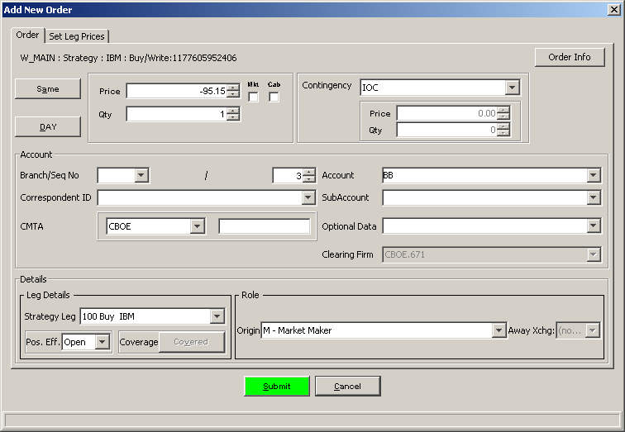

Same or Opposite
CPS orders can be submitted either as ‘Same’ or ‘Opposite’. ‘Same’ indicates that the trader wants to do the spread as already defined while ‘Opposite’ indicates that the trader wants to do the opposite of the defined spread.

For example, let us assume that a CPS product is defined as follows:
- Buy 100 IBM Shares
- Sell 1 IBM Jul 2007 95 Call

Now, if the trader wants to do the spread as defined above, then he must specify ‘Same’. And if he wants to do the ‘Opposite’ (i.e. Sell 100 IBM shares and Buy 1 IBM Jul 2007 95 Call), then he must specify ‘Opposite’.

(Note: ‘Same’ and ‘As Defined’ refer to the same side of the CPS order book.)

CPS Order Book
CBOEdirect will maintain a book for every unique CPS product, with the ‘Same’ orders on one side and the ‘Opposite’ orders on the other. The orders in each group will be sequenced in price from the most negative of the debits at the top (best) to the most positive of the credits at the bottom (worst).

Ordinarily, the prices on one side would be negative and the prices on the other side, positive. It is possible that the top orders of the two sides are both positive. The system will disseminate the ‘top of the book’ prices to the participants only, not to OPRA.

Note: As the system will not monitor the stock leg market, for this phase, it must be considered that incoming CPS orders will not be booked (i.e. if an order is not executed then it would be routed back to TPF but not booked in any circumstances). This means that there will be an empty CPS order book for now.

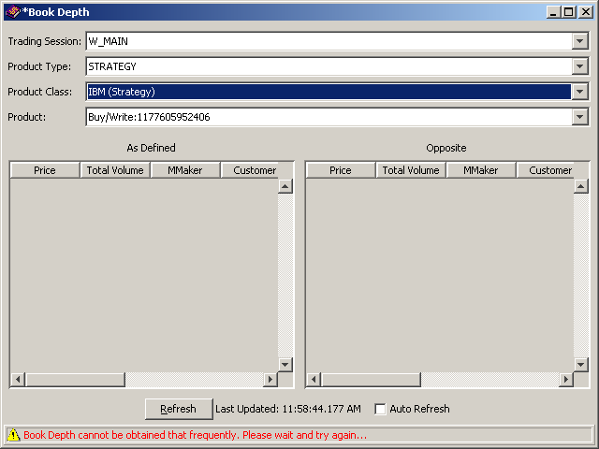

CPS Trading – High Level Process Flow

System View

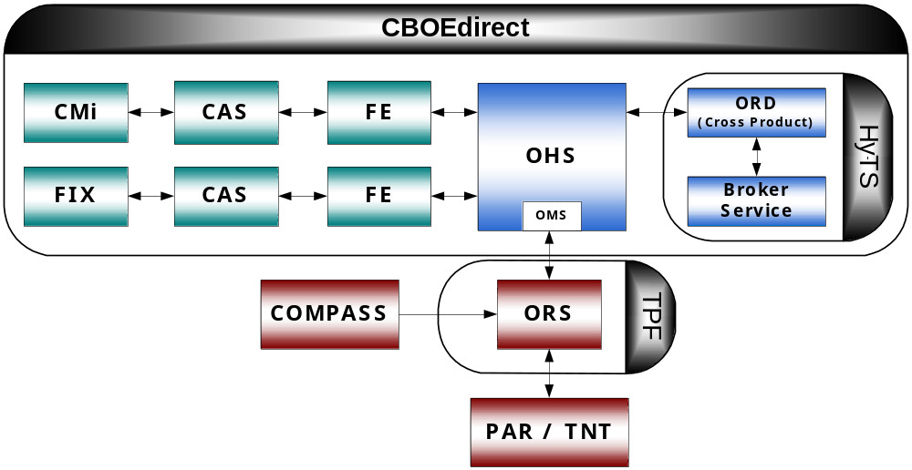

Stage 1 – Initial Order Entry to OHS

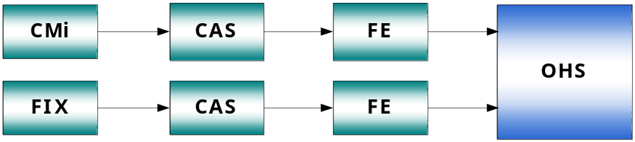

- A CPS Order created either through CMi or FIX APIs and routed via CAS and FE reaches OHS.
- OHS validates the order on the following in addition to the basic order handling conditions validated as of date.
  - Is the incoming order an I-order?
    - If ‘Yes’ then the CPS order is not accepted and is rejected back to the sender.
    - If ‘No’ then the CPS order is routed to TPF

Note: At this stage, the existing validation to check if the ‘Leg Price’ exists or not must be skipped for CPS incoming orders.

Error Codes and Messages
Refer Section below

Stage 2 – Order Routing from OHS to TPF
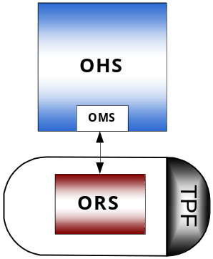

The OHS does the following with a first time incoming CPS order.
- OHS routes the incoming order to ORS in TPF.
- ORS validates the order.
- ORS returns the order back to OMS in OHS.

Stage 3 –Order Routing from TPF to OHS and OHS to ORD

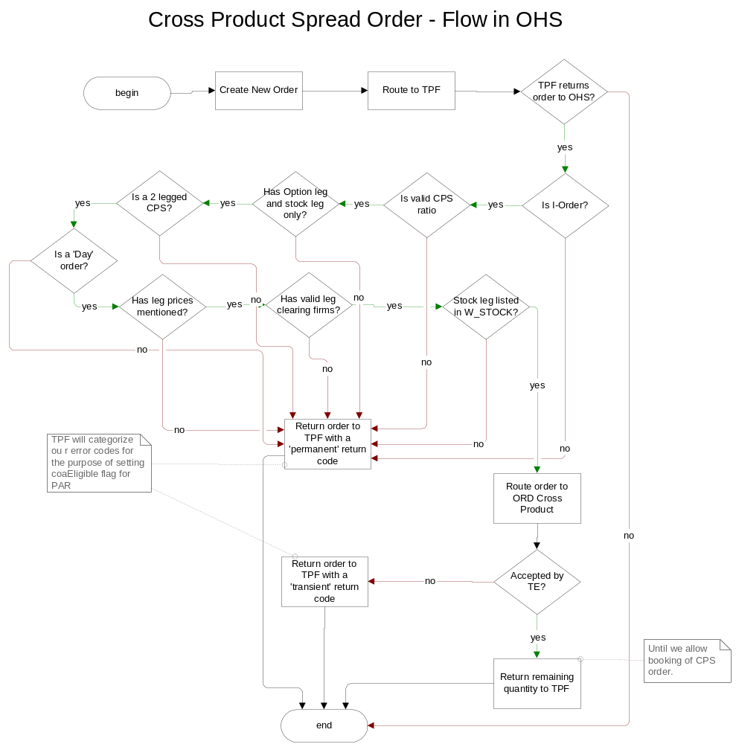

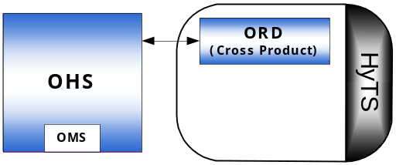

The OMS in OHS does the following after receiving a TPF routed CPS order.
- OMS validates the incoming order for the following additional conditions in addition to the existing validations as of date.
  - Is the incoming order an I-order?
    - If ‘No’, then OMS checks for the next condition.
    - If ‘Yes’ then OMS returns the order back to TPF with a ‘permanent’ return code.
  - Is the CPS Product 2 legged?
    - If ‘Yes’ then OMS checks for the next condition.
    - If ‘No’ then OMS returns the order back to TPF with a ‘permanent’ return code.
  - Does the CPS product have a stock leg and an option leg only?
    - If ‘Yes’ then OMS checks for the next condition.
    - If ‘No’ then OMS returns the order back to TPF with a ‘permanent’ return code.
  - Is the leg ratio valid?
    - If ‘Yes’ then OMS checks for the next condition.
    - If ‘No’ then OMS returns the order back to TPF with a ‘permanent’ return code.
  - Is the stock leg listed in CBSX?
    - If ‘Yes’ then OMS checks for the next condition.
    - If ‘No’ then OMS returns the order back to TPF with a ‘permanent’ return code.
  - Are the Leg Clearing Firms valid?
    - If ‘Yes’ then OMS checks for the next condition.
    - If ‘No’ then OMS returns the order back to TPF with a ‘permanent’ return code.
  - Is it a ‘DAY’ CPS order?
    - If ‘Yes’ then OMS checks for the next condition.
    - If ‘No’ then OMS returns the order back to TPF with a ‘permanent’ return code.
  - Is there a Leg price mentioned?
    - If ‘No’, then OMS routes the order to ORD Cross Product.
    - If ‘Yes’ then OMS returns the order back to TPF with a ‘permanent’ return code.
- And based on the above validations getting fulfilled or not as specified above, the system does the following.
  - If all the validations are fulfilled then OMS routes the order further onwards to ORD Cross Product.
  - If all the validations are not fulfilled then OMS returns the order back to TPF with the applicable return code.

Business Rules
- The ORD referred in this document for CPS routing and trading is the new ‘ORD Cross Product’.
- As of date the Exchange Give-up firm validations at the order level are as follows.
  - If the trader is a Exchange Broker, then the system checks if the Firm # is valid or not
  - If the trader is a Market Maker, then the system checks if the user.account.firm = order.firm
  - If the trader is not an Exchange Broker and a Market maker, then the system checks if user.firm = order.firm
- The new Leg Clearing Firm validations must be implemented as follows.
  - If in the Trader GUI, the trader does not specify the Stock Clearing Firm, then the system must do the following.
    - Pick the value of the 'Clearing Firm' field that would be in the format of 'CBOE.XXX' where XXX is the firm number.
    - Create a clearing firm using the above firm number and "CBOEW" as the prefix.
    - Assign this new clearing firm ‘CBOEW.XXX’ to the Stock leg.
    - Validate both the leg clearing firms as follows.
      - The stock and option leg clearing firms are known and active firms.
      - If not valid, then throw a data validation exception with new error code ‘INVALID_CLEARING_FIRM’ and the text message indicating the reason.

Return Codes and Messages
- The ‘INVALID_STRATEGY’ error code is used in the following validations.
  - Is the CPS Product 2 legged?
  - Does the CPS product have a stock leg and an option leg only?
  - Is there a Leg price mentioned?
- The ‘INVALID_TIME_IN_FORCE’ error code is used in the following validations.
  - Is it a ‘DAY’ CPS order?

For the return codes for all other validations, refer Section below

Stage 4 – Order validation by ORD

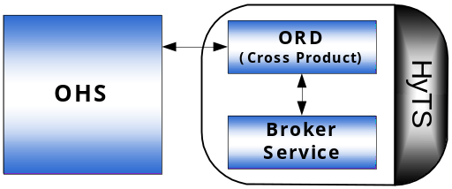

The ORD in the HyTS does the following after receiving a TPF routed CPS order from OHS.
- ORD validates the incoming order for the following additional conditions in addition to the existing validations as of date.
  - Is the incoming CPS order an I- order?
    - If ‘No’, then ORD routes the order to the Broker service in the HyTS.
    - If ‘Yes’ then ORD returns the order back to OHS with a ‘permanent’ return code.
- ORD does all the above trading validations to see if the HyTS can accept the order.
  - If all the validations are fulfilled then ORD routes the order to the Broker service in the HyTS.
  - If all the validations are not fulfilled then ORD returns the order back to TPF via OHS, with a ‘transient’ return code.

(Note: All the existing validations as of date for complex spread orders that have been skipped until now for CPS orders must be turned on and applied now as and when required.)

Return Codes and Messages
TBD – Refer Section below

Stage 5 – Order Acceptance and Execution in CBOEdirect

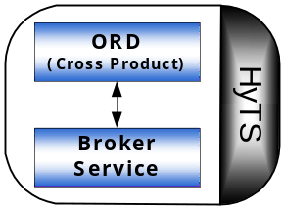

- The Broker service in the HyTS accepts the order from ORD.
- The Broker service executes the CPS order.
- If executed and there is some quantity remaining, then the HyTS routes it back to TPF via OHS.

Matrix of Validations
The following are all of the new set of validations for CPS order routing from OHS to ORD in the trade server.

Business Rule | OHS | OMS | ORD
Is it an I-order? | X | X | X
Skip the leg price check validation. | X
Is it a 2-legged CPS? |  | X
Are there a Stock leg and an option leg? |  | X
Is the leg ratio 1:100? |  | X
Is the stock leg listed in CBSX? |  | X
Is it a ‘DAY’ CPS order? |  | X
Is there a leg price mentioned? |  | X
Are the Stock Clearing Firm and Option Clearing Firm numbers valid? |  | X

CPS Order Execution in CBOEdirect– Processing Flow
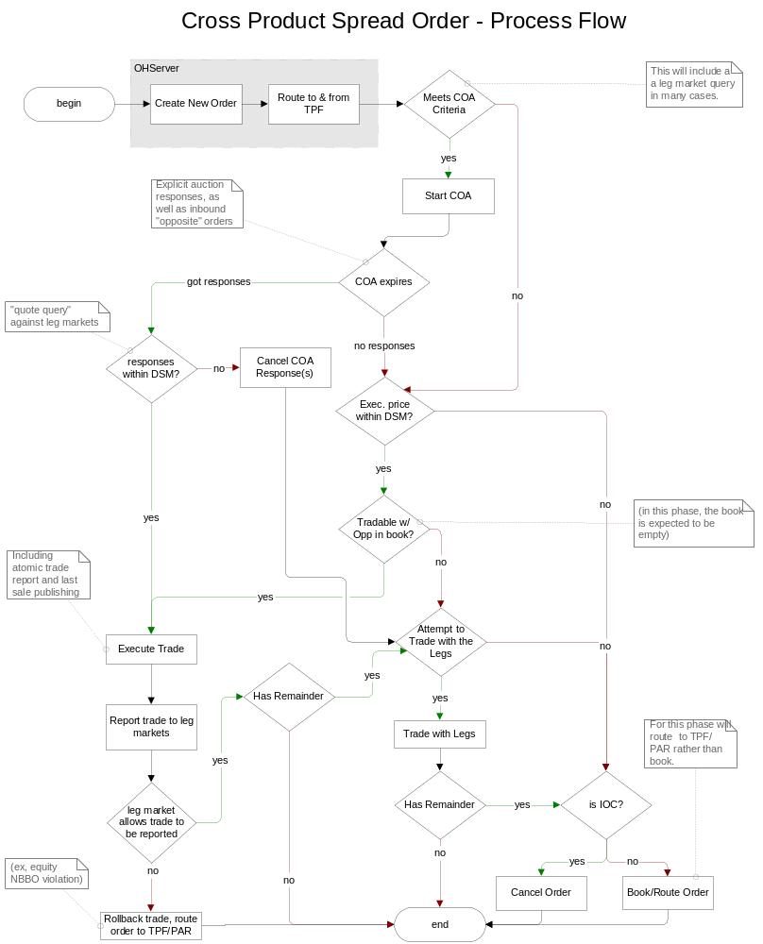

Basic Flow
CBOEdirect does the following upon the receipt of a valid incoming CPS order from OHS.
- The system validates the CPS order.
  - If the CPS order meets the trading eligibility criteria then the system does Basic Flow – Step 2.
  - If the CPS order does not meet the trading eligibility criteria then the system does not accept the order and returns it back to TPF with the appropriate return reason code.
- The system does the following.
  - Gets the market data for the CPS product legs
    - NBBO
    - CBOE Current Market or BBO
    - CPS product state
  - Calculates the Derived Spread Market (DSM) based on NBBO.
- The system then checks for the marketability of the individual leg markets.
  - If both the legs are tradable then the system does Basic Flow – Step 4.
  - If both the legs are not tradable then the system does Alternative Flow1.
- The system validates the following trading properties for starting COA.
- AuctionEnabled
- AuctionTimeToLive
- AuctionMinPriceIncrement
- AuctionMinQuoters
- AuctionReceiverTypes
- AuctionMinMaxOrderSize
- SizeIncreasePercentageForNewRfp
- PriceProtectPercentage
- AllowMarketOrder
  - If all the above criteria are satisfied then the system does Basic Flow – Step 5.
  - If all the above criteria are not satisfied then the system does Alternative Flow1.
- Using the market data and DSM gathered in Basic Flow – Step 2, in conjunction with the incoming CPS order’s details, the system calculates the following.
  - Starting Auction Price
  - Maximum Auction Volume
- The system does the Pre-Auction cleanup.
- The system starts the COA (i.e. initiation).
- Based on certain pre-defined criteria the system ends the COA (i.e. normal expiration or pre-mature expiration).
- Based on the auction responses, the system does the following.
  - If the auction got some responses then the system does Basic Flow – Step 10.
  - If the auction did not get any responses then the system does Alternative Flow 1.
- The system does the following again.
  - Gets the market data for the CPS product legs
    - NBBO
    - CBOE Current Market or BBO
    - CPS product state
  - Calculates the Derived Spread Market (DSM) based on NBBO.
- The system checks if the following are within the DSM.
- COA auction responses
- New inbound ‘Opposite’ orders in the auction book, received during COA
- Resting orders in the CPS order book
  - If any of the above is tradable then the system does Basic Flow – Step 12.
  - If none of the above is tradable then the system does Alternative Flow2.
- The system trades the auctioned CPS order against the following in that order.
  - COA auction responses
  - New inbound ‘Opposite’ orders in the auction book, received during COA
  - Resting orders in the CPS order book
- The system executes the trade.
- The system reports the trade to the individual leg markets.
  - If the leg markets allow the trade to be reported, then the system does Basic Flow - Step 15
  - If the leg markets do not allow the trade to be reported, then the system rolls back the trade and routes the CPS order to TPF/PAR.
- The system checks for remainder in the executed CPS order.
  - If the CPS order has a remainder, then the system does Alternative Flow3.
  - If the CPS order does not have any remainder then trade execution is completed.
- The process ends.

Alternative Flows

Alternative Flow1
- Starting at Basic Flow – Steps 4(b) or 9(b), the system does the following again.
  - Gets the market data for the CPS product legs
    - NBBO
    - CBOE Current Market or BBO
    - CPS product state
  - Calculates the Derived Spread Market (DSM) based on NBBO.
- The system checks if the order is tradable against resting orders in the ‘Opposite’ side of the CPS order book and also the new inbound opposite sided orders in the auction book that were received during COA.
  - If tradable with the opposite CPS orders then the system does Basic Flow Step 13.
  - If not tradable with the opposite CPS orders then the system does Alternative Flow3.

Alternative Flow2
- Starting at Basic Flow - Step 11(b), the system cancels all the received COA auction responses.
- The system checks if the order is marketable against the individual leg markets.
  - If marketable against the individual leg markets then the system does Alternative Flow3.
  - If not marketable against the individual leg markets then the system does Alternative Flow4.

Alternative Flow3
- Starting at either Basic Flow - Step 15(a) or Alternative Flow1 – Step 2(b) or Alternative Flow2 – Step 2(a), the system does the following.
  - Gets the market data for the CPS product legs
    - NBBO
    - CBOE Current Market or BBO
    - CPS product state
  - Calculates the Derived Spread Market (DSM) based on NBBO.
- The system checks for legal leg markets and if either the incoming full order or the remainder of the partially executed order is tradable against the resting orders in the individual leg books.
- If the remainder or full order is tradable against the individual leg books then the system does Step 3.
- If the remainder or full order is not tradable against the individual leg books then the system does Alternative Flow4.
- The system executes the trade.
- The system checks for remainder in this executed remainder or full order.
  - If the executed remainder or full order has some remainder, then the system does Alternative Flow4.
  - If the remainder or full CPS order does not have any remainder then trade execution is completed.
- The process ends.

Alternative Flow4
- Starting at either Alternative Flow1 – Step 2(b) or Alternative Flow2 – Step 2(b) or Alternative Flow3 – Step 4(a), the system checks if the CPS order has an IOC instruction.
  - If IOC then the system cancels the order, even if it is the remainder or the full order.
  - If not IOC then the system routes the order to TPF, even if it is the remainder or the full order.
- The process ends.

Business Rules
TBD

CPS Order Locking

Basic Flow

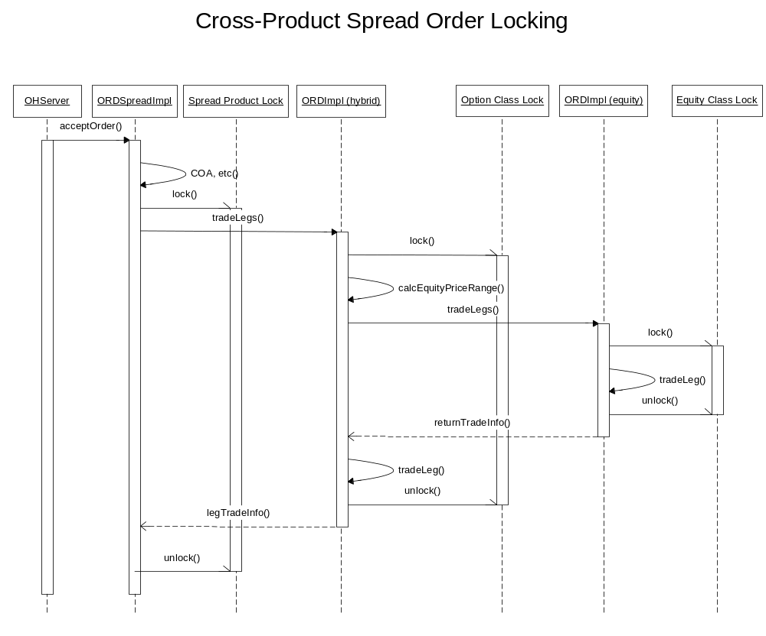
- OHS receives the order from TPF.
- OHS sends the order to ORD STS (Spread Trade Server).
- ORD STS accepts the order.
- ORD STS starts COA.
- ORD STS ends COA.
- ORD STS starts executing the trade based on the COA responses.
- ORD STS locks the CPS product (i.e. product level locking).
- ORD STS attempts to trade on the legs.
- ORD HTS (Hybrid Trade Server) locks the option class (i.e. class level locking).
- ORD HTS calculates the stock leg’s price range.
- ORD HTS attempts to trade on the stock leg.
- ORD ETS (Equity Trade Server) locks the stock class (i.e. class level locking).
- ORD ETS executes the trade on the stock leg.
- ORD ETS unlocks the stock class.
- ORD ETS returns the stock leg execution info to ORD HTS.
- ORD HTS executes the trade on the option leg.
- ORD HTS unlocks the option class.
- ORD HTS returns the option leg execution info to ORD STS.
- ORD STS unlocks the CPS product lock.

CPS Order Trading of TPF/PAR routed orders
The order handling instructions that must be accepted from TPF/PAR for returning CPS orders are as follows.

Instruction Type | Instruction Code | Execution Rule
T/A | R | Not COA.  Trade against both the CPS order book and the individual leg books as well and return the remainder to PAR.
Book | B | Do COA and return the remainder to PAR.
Auction | A | Do COA and return the remainder to PAR.

CPS Post-trade Activities
The system must perform the following reporting activities when a CPS order is traded (i.e. post-trading broadcast events).
- Disseminate the Fill Report for the CPS product and for each of the individual legs to the CPS order source.
  - Fill Report for the CPS
  - Fill Report for option leg of the CPS
  - Fill Report for stock leg of the CPS
- For the CPS order, disseminate the Trade Report to OCC via CTM.
- For each of the individual legs, disseminate the Current Market Data and Last Sale Reports to OPRA via COPP.
  - For the option leg, the prefix will be ‘SPRD’ indicating that the last sale is part of a CPS trade.
  - For the stock leg, no separate indication is provided to highlight CPS participation.
- Insert the last sale report of the CPS traded legs in the Market History for the individual leg’s products (series) with some indication that the last sale is part of a spread trade.
- Insert the last sale report of the CPS in the Market History for the CPS product.
- Update the Order History with three entries (one for CPS and two for the legs).

Reporting of CPSB – CPSB Trade

 | W_MAIN (CPS and Option Leg) | W_STOCK (Equity Leg)
Database Related Events
Order | Updated | N/A
Order Relation | N/A | N/A
Order History | Updated | N/A
Market History | Updated | Updated
Trade Report | Updated | Updated
Broadcast Events
Fill Reports | Generated | N/A
Trade Reports | Generated | Generated
Current Market | Generated | Generated
Last Sale Reports | Generated | Generated

Reporting of CPS Leg Market Trading

 | W_MAIN (CPS and Option Leg) | W_STOCK (Equity Leg)
Database Related Events
Order | Updated | Updated
Order Relation | Updated | Updated
Order History | Updated | Updated
Market History | Updated | Updated
Trade Report | Updated | Updated
Broadcast Events
Fill Reports | Generated and disseminated to owner | Generated and disseminated to W_MAIN
Trade Reports | Generated | Generated
Current Market | Generated | Generated
Last Sale Reports | Generated | Generated

Trade Report

 | W_MAIN | W_STOCK
For Non-Cross Product Spread Trades | Trade Report  ⎣ SPRD  ⎣ Leg1  ⎣ Leg2 | N/A
For Cross Product Spread (CPS) Trades | Trade Report  ⎣ CPS  ⎣ Option Leg | Trade Report  ⎣ Stock Leg

Note:
- The Trade Report will have new fields, ‘BUYERSESSION’ and ‘SELLERSESSION’ which would indicate the trading session (i.e. W_MAIN or W_STOCK) of the CPS order in addition to the Order ID. And note that ‘BUYER’ corresponds to Same/As Defined and ‘SELLER’ corresponds to Opposite sided orders.
- In the fill report of the Equity leg of a CPSB - CPSB trade, the session displayed is W_MAIN as it is filled by W_MAIN.
- In the fill report of the Equity leg of a CPS Leg market trade, the session displayed is W_STOCK as it is filled by W_STOCK.

Fill Report Changes
In the Fill Report, for the stock leg, under the ‘Fill Information’ section, the ‘Extensions’ field is generally empty. This ‘Extensions’ field must be populated with “207=W”.

Note: FIX Tag “207” stands for Security Exchange (i.e. to identify the primary exchange for options). And the code “W” represents the Reuters Code for Chicago Board Options Exchange.

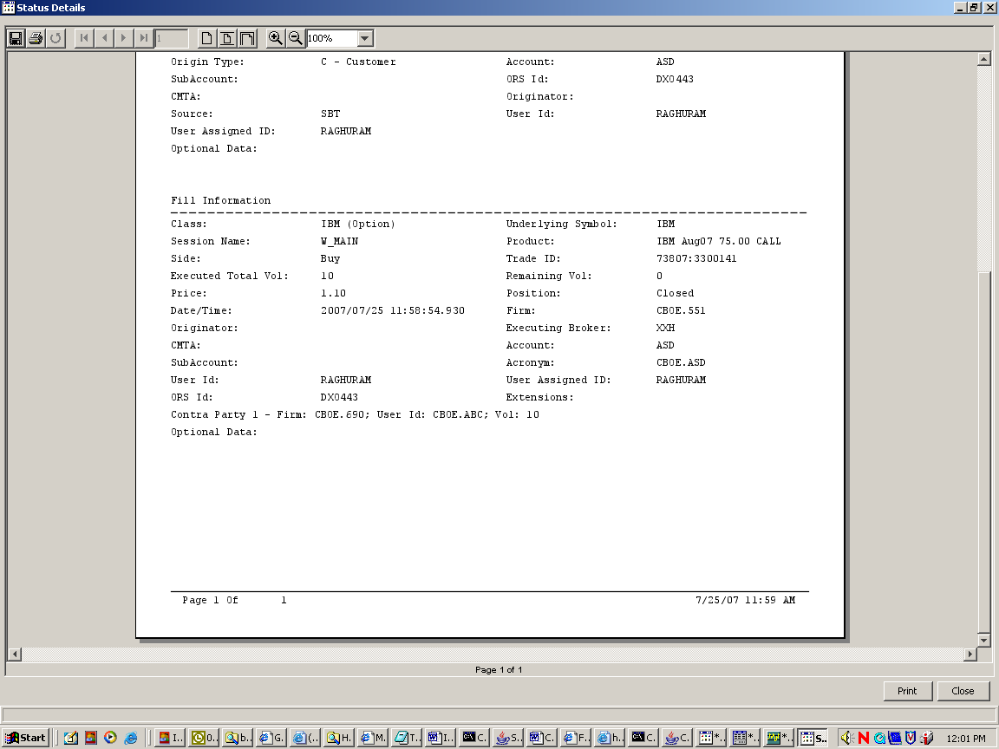

Trade Report Changes
In the SA GUI, click the following: Start ➔ Trades ➔ Trade Query ➔ Create New Window
This opens up the ‘Trade Query’ window, in which under the ‘Query’ tab and in the ‘Trade Reports’ section, for all the three products (i.e. the CPS product and the two legs) the ‘Type’ column must be populated as follows.
- For CPSB – CPSB trades, the ‘Type’ column must show the value of “CROSS_PRODUCT_CROSS_TRADE”.
- For CPS Leg Market trades, the ‘Type’ column must show the value of “CROSS_PRODUCT_LEG_TRADE”.

Note:
- “CROSS_PRODUCT_CROSS_TRADE” is referred in the database by “S”
- “CROSS_PRODUCT_LEG_TRADE” is referred in the database by “X”
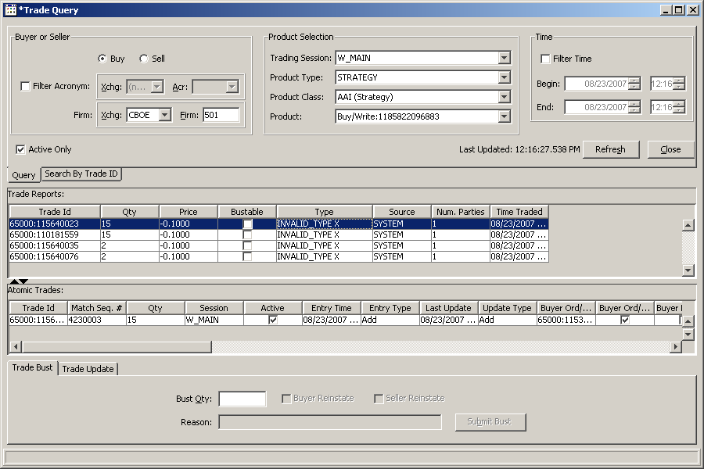

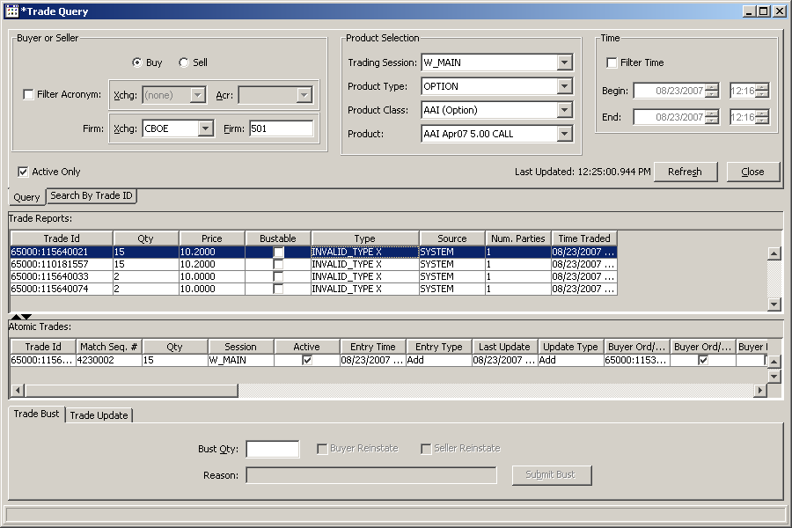

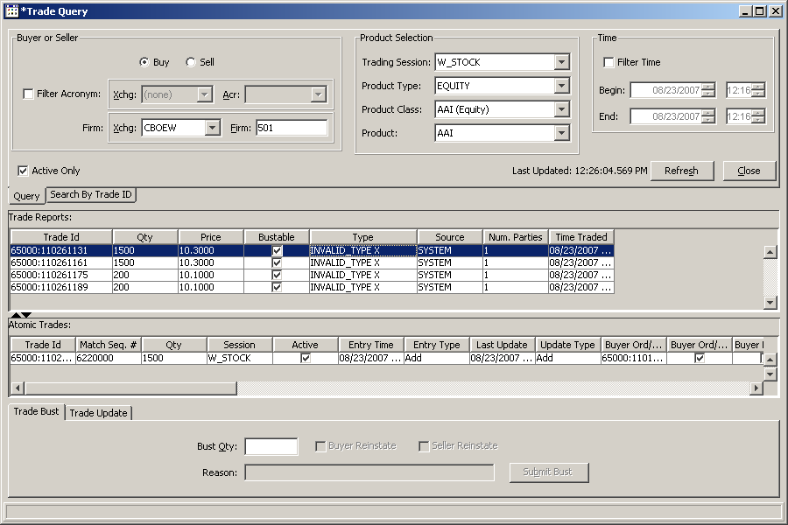

End of Day Process

Expiring CPS Orders
At the end of the trading day, as part of the end-of-day process, the system purges (i.e. deletes) all the ‘Day’ CPS orders.

Trade Busts
Currently there is no automated provision in the CBOEdirect GUI to do trade bust for strategy trades. And so if required to do any busts, the Help Desk handles each request individually and executes it manually. Hence this will continue to be the same for CPS trades as well. No GUI changes are suggested as of date.

Deletion of CPS Products
The system will delete all CPS products that have no orders at the end of the day. CPS products that have ‘Day’ orders, which expire at the end of the day, will not be deleted.

CBOEdirect GUI Requirements for CPSs

Clearing Firm
In the CBOEdirect Trader GUI, a new clearing firm field for the stock leg must be added. The following are the changes. The new field must be located and displayed as follows.
- The new field must be labeled as "Stock Clearing Firm"
- It must be displayed in the ‘Add New Order’ window only for a CPS order.
- In the ‘Add New Order’ window with a Market Maker’s login, it must be placed right below the ‘CMTA’ field.
- In the ‘Add New Order’ window with a Broker’s login, it must be placed right below the ‘Originator’ field.

(Note: The current ‘Clearing Firm’ field name must NOT be relabeled or modified. Also for a CPS order, irrespective of the number of stock legs and options legs, there will be only one clearing firm that would be allowed for all of the option legs and only one other different clearing firm (if any) for all of the stock legs.)

Trader is a Market Maker
In the 'Add New Order' window, the following needs to be implemented.
- The "Firm" name selected in the 'Details' tab of the 'User Management' window, must be displayed by default in the "Clearing Firm" field of the 'Add New Order' window.
- The “Stock Clearing Firm” must NOT be defaulted with any value.
- The "Clearing Firm" and "Stock Clearing Firm" fields must be grayed out and not editable.

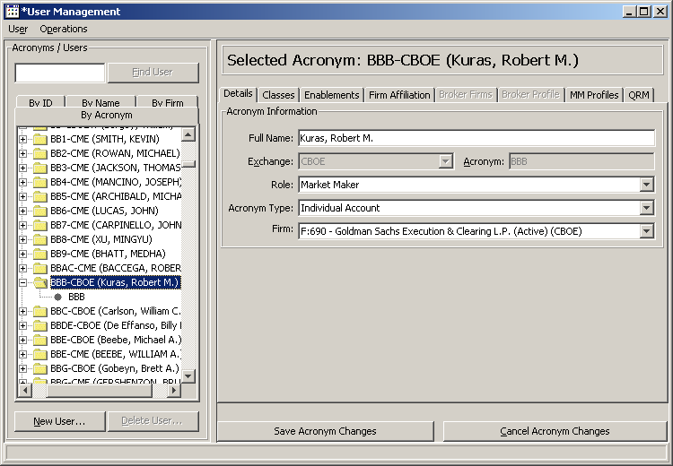

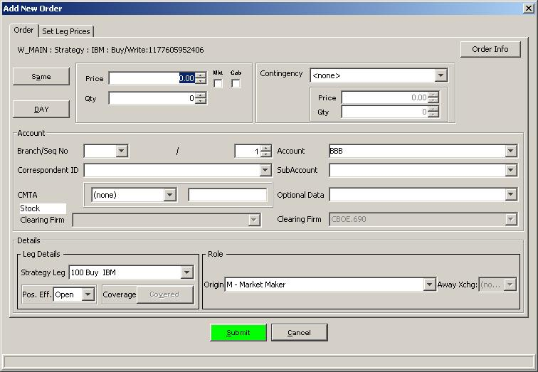

Trader is a Broker Dealer

Trader is a Broker Dealer with no ‘Assigned Give-up Firms’
In the 'Add New Order' window, the following needs to be implemented.
- If there are no “Assigned Give-up Firms” in the ‘Broker Firms’ tab of the 'User Management' window other than the "Firm" name selected in the 'Details' tab, then the system must by default display the "Firm" in the " Clearing Firm" field.
- The “Stock Clearing Firm” must NOT be defaulted with any value.
- The "Clearing Firm" and "Stock Clearing Firm" fields must NOT be grayed out but must NOT be editable either.

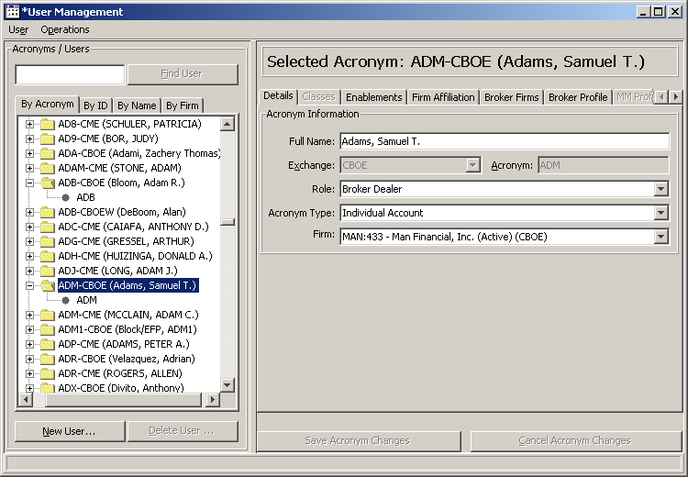

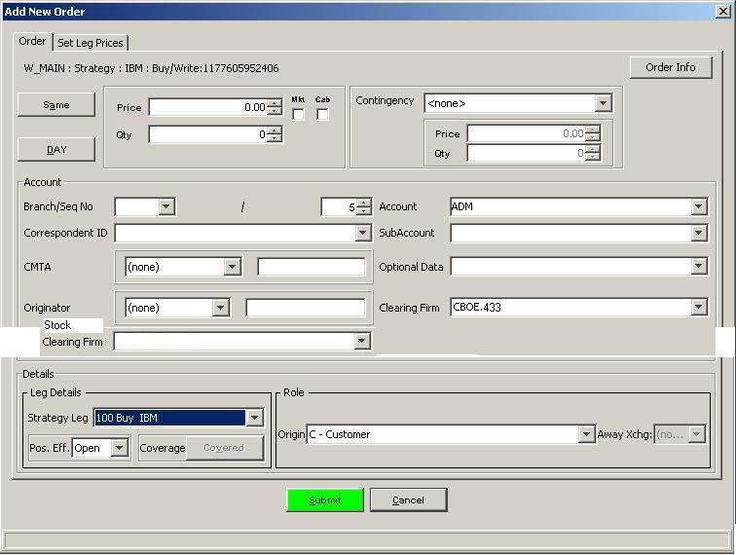

Trader is a Broker Dealer with ‘Assigned Give-up Firms’
In the 'Add New Order' window, the following needs to be implemented.
- If there are one or more “Assigned Give-up Firms” in the ‘Broker Firms’ tab of the 'User Management' window then instead of the "Firm" name from the 'Details' tab, the system must automatically display those “Assigned Give-up Firms” in the "Clearing Firm" field drop-down.
- The “Clearing Firm” must be defaulted with the first value in the drop-down list.
- The “Stock Clearing Firm” must NOT be defaulted with any value.
- For both the “Stock Clearing Firm” and “Clearing Firm” fields, the trader must be able to modify his selection from a drop-down list.
- The “Clearing Firm” drop-down list must only display “Assigned Give-up Firms” which do not start with “CBOEW” (refer the screen shot below).
- The “Stock Clearing Firm” drop-down list must only display “Assigned Give-up Firms” which start with “CBOEW” (refer the screen shot below).
- The clearing firm fields must NOT be grayed out.

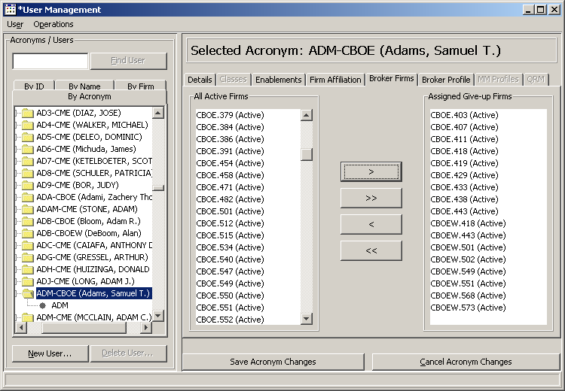

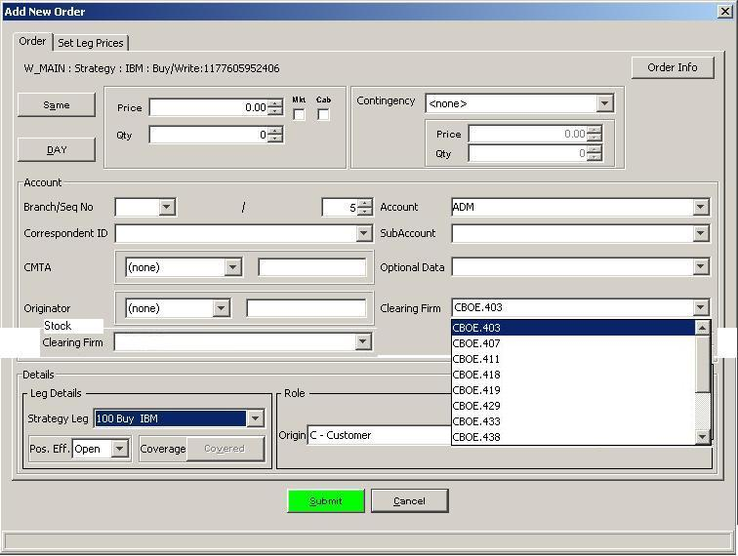

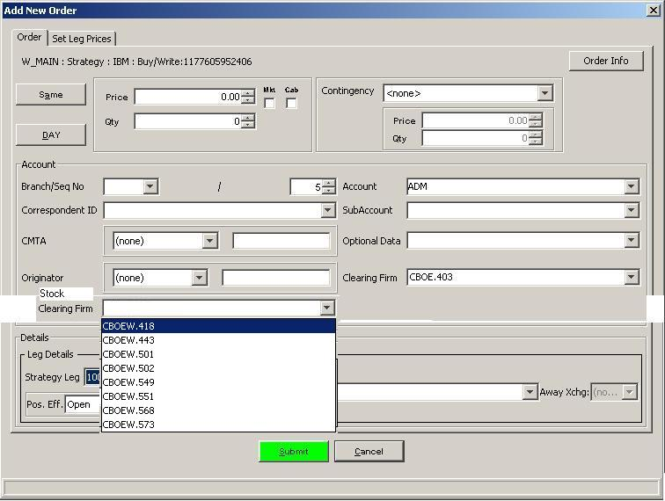

Business Rules
The system must validate the Stock and Option Clearing Firm numbers.

Refer Section above for further details.

Order Information
In the Add New Order window, in the top right corner, when the trader clicks the ‘Order Info’ button, currently it appears that the information provided in the ‘Order Information’ window is all about just multiplying the Price and Quantity to give a net cost or so. And also that value seems to be not of much relevance to CPS order creation.

<<TBD if there are any changes expected>>
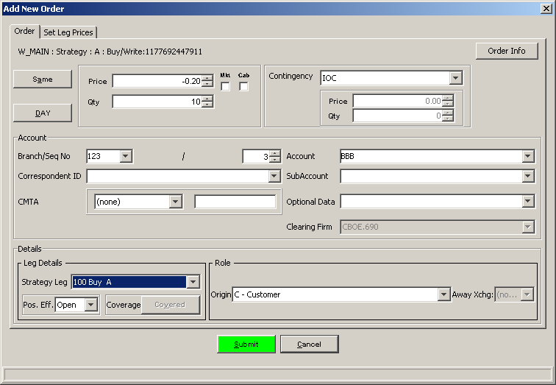

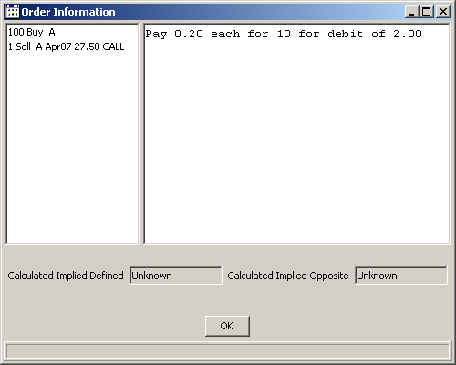

New Error Messages
- If the incoming CPS order is an I-Order then the system generates an ‘INVALID_ORIGIN_TYPE’ message.

Derived Spread Market
The system calculates the DSM for the following:
- Before starting the COA.
- After receiving COA auction responses.
- When the order is not COA eligible and is being attempted to trade against the CPS order book.
- Before executing the trade on the leg markets.

Calculation of the Derived Spread Market (DSM)
The CBOEdirect Trading Engine calculates the Derived Spread Market (DSM) price based on the NBBO.

For example, let us assume that a CPS product is defined as below.

- Buy 500 IBM Shares
- Sell 5 IBM Jul 2007 95 Call

The system will calculate the lowest possible ratio for the leg quantities to be 5:500 => 1:100 => 1:1
(Note: 1 option contract = 100 shares)

The current markets for the two legs are as below.

CPS Leg(s) | Quote (Bid – Ask)
IBM Stock | 97.00 – 97.25
IBM Jul 2007 95 Call | 2.10 – 2.30

Hence the CPS product’s derived quote or implied market is 94.70 debit and 95.15 credit, as calculated below.

Buy Stock / Sell Call  Same As or Defined  (Bid) | Sell Stock / Buy Call  Opposite  (Ask)
(-97.00 * 1) + (2.30 * 1) | (97.25 * 1) + (-2.10 * 1)
-94.70 | +95.15

Using NBBO for DSM Calculations
- Currently the stock quotes used for DSM are of the BBO and the W_STOCK quotes are not very aggressively priced. This could result in a trade-through. Hence to change that and to be using the NBBO quotes, a configuration flag must be provided. And when this configuration flag is set to “True” in the EquityTS, then the market quote query responses to the HybridTS will be populated with the NBBO Price & Volume values rather than just the local market. Therefore the current deployment must have the flag set to “TRUE”.
- Currently the option quotes used for DSM are of BBO as well. The system must use NBBO quotes (i.e. the NBBO configuration flag is set to “TRUE”).

COA for CPS Orders
New CPS orders will route to TPF from Compass, BERS, FIX or CMi; and returning orders will route from PAR.

COA Configurations
For COA eligibility, a CPS order must have the following trading properties filled.

Field Name | Default Value
AuctionEnabled | TRUE
AuctionTimeToLive | Lower Limit = 2000; Upper Limit = 2000
AuctionMinPriceIncrement | 1
AuctionMinQuoters | 1
AuctionReceiverTypes | Class Quoter = 1
AuctionMinMaxOrderSize | Min = 1; Max = 99999
SizeIncreasePercentageForNewRfp | 0.5
PriceProtectPercentage | 0.05
AllowMarketOrder | TRUE

Price Protect Percentage related changes
For COA of CPS orders, the trading property of Price Protect Percentage is to be completely ignored for all price calculations.

Order Handling Instructions from TPF
- All CPS orders incoming from TPF to CBOEdirect, except for returning orders from PAR, must be specified with the instruction type ‘Auction’ (i.e. ‘A’).
- TPF will not modify the trading restrictions sent by PAR.
- While routing orders to PAR, TPF must mark the orders with the appropriate return code such that if the return code is of a ‘Permanent’ reject type then TPF must not route the CPS order back to CBOEdirect again (refer Section below).

Order Handling Instructions from PAR
The order handling instructions that must be accepted from TPF/PAR for returning CPS orders are as follows.

Instruction Type | Instruction Code | Execution Rule
T/A | R | Not COA.  Trade against both the CPS order book and the individual leg books as well and return the remainder to PAR.
Book | B | Do COA and return the remainder to PAR.
Auction | A | Do COA and return the remainder to PAR.

Note: TPF must not modify any of the trading properties/handling instructions set by PAR.

Receiving a CPS Order routed from TPF/COMPASS
When a CPS order is received from TPF/COMPASS, for COA eligibility, the information of the order itself should be the same (as detailed in the section above) as that for an order not routed from TPF/ COMPASS. In addition, the following information must also be received:

Execution Price
The ‘Execution Price’ may be specified or may not be. When TPF does not specify this price, no price is assumed.

Maximum Execution Volume
The ‘Maximum Execution Volume’ may be specified or may not be. When TPF does not specify this volume, the CPS order’s original quantity will be the ‘Maximum Execution Volume’.

COA Process

Pre-Auction Criteria

Starting Auction Price
The system will choose the ‘Starting Auction Price’ as the best price (i.e. from the market point of view, a better price is a price which improves the market. An order that is willing to pay more money, or willing to receive less money is an order with better price) of the following.
- ‘Execution Price’ in the instruction (if any).
- Order price (if it is a limit order)
- X% of the DSM (if it is a market order)
- Best of Strategy Market (i.e. better of TSB and DSM).

Maximum auction volume
The system will choose the ‘Maximum Auction Volume’ as the least of the following.
- ‘Maximum Execution Volume’ in the instruction
- Order’s remaining quantity

Auction Process
The system does the following activities to start and execute the auction for an incoming CPS order, when it is eligible to be auctioned as COA.

Pre-Auction Cleanup
The system checks the following.
- Checks if there is an on-going COA on the CPS product itself.
- Checks if there is an on-going ‘Quote Trigger’ (but as there are no quotes and quote triggers for CPS, this check would not result anything).

Starting Auction
The system checks the following and starts the auction accordingly.
- If there is no on-going auction on the CPS product then the system starts a new auction; sends out the RFP; and remembers the DSM at the time when the auction started.
- If there is an on-going auction on the CPS product then the system either joins the auction or ends it to start a new auction based on certain pre-defined conditions as detailed further below.

During Auction
The system does the following during the auction.
- Does not monitor any Quote Lock or Quote Trigger or Auction conditions on the legs, which are triggered in event of the legs’ current market being updated.
- Collects all RFP responses.

Joining an Existing Auction
An incoming non-auction-response order (like a Customer order) on the SAME side of the auction where the Incoming order price is EQUAL or WORSE than the Auction ORDER Price and also is EQUAL or BETTER than the Auction START Price must JOIN the currently ongoing auction.

Auction Expiration

Normal Expiration
The COA must end normally when the specified auction time expires.

Pre-mature Expiration w.r.t. leg markets
Currently there are no leg market related conditions that prematurely must expire the COA for a CPS product.

Pre-mature Expiration w.r.t. CPS product
The COA must end prematurely if any one of the following conditions on the CPS product is fulfilled.
- An incoming non-auction-response order (like a Customer order) on the SAME side of the auction meeting any of the conditions listed below must EXPIRE the current auction.
  - If Incoming order price is BETTER than the Auction ORDER Price
  - If Incoming order price is WORSE than the Auction START Price and it crosses the OPPOSITE side Best Market

Note: (i) This new CPS order will simply EXPIRE the on-going Auction and must not participate in the allocation of the auction against the auction responses, and instead must try to start a new auction for this new incoming CPS order.
(ii) The Auction START Price is always EQUAL or BETTER than the Auction ORDER Price (i.e. from the auction response point of view).

- An incoming non-auction-response order (like a customer order) on the OPPOSITE side of the auction with a BETTER price than the auction START price must EXPIRE the current auction and then can participate in the auction by trading with the auctioned order.

During Auction Expiration
Around the time when the auction is about to expire (i.e. either normally or pre-maturely), the system does the following:
- Expires all the timer based 'HoldUps' (i.e. Quote Triggers and Auctions) on the option leg. (Note: this is not applicable to stock leg, as they do not have any 'holdups').
- Calculates the DSM and checks to see if the auctioned order can be traded or not such that if the Auction ORDER Price is EQUAL or WORSE than the current market price of the SAME auction side, then the auction will be expired without any trades.

Auction Allocation
After auction expiration, if eligible to be traded, the auctioned order will be traded with the prioritized parties of the other side and allocated as follows:
- Price priority
- ‘Customer’ origin priority
- The rest of them are allocated via CUMA

And lastly, if the incoming opposite order has quantity remaining after trading with the auctioned order, then the system starts a new auction for that order with the remaining quantity.

(Note: This Auction Allocation part has not been modified for CPS project.)

Fills for joined orders
After auction expiration, for fills of the orders joined during COA
- When trading against the auction responses or incoming opposite sided orders, the joined orders are combined and filled as one.

Fill reports | Orders in COA | Joined ➔ Trade | Responses / Opposite Order | Fill Reports
CPS Order1  Option Leg1  Stock Leg1 | CPS1 (20 Qty) ➔ | (20+30) ➔ ⬅ 50 | ⬅ CPS3 (50 Qty) | CPS Order3  Option Leg3  Stock Leg3
CPS Order2  Option Leg2  Stock Leg2 | CPS2 (30 Qty) ➔ | (20+30) ➔ ⬅ 50 | ⬅ CPS3 (50 Qty) | CPS Order3  Option Leg3  Stock Leg3

- When trading against the leg markets, at the same price point each CPS order must be filled individually and thus results in its own set of three fill reports each. (Note: This a modification of the existing implementation.)

Current day implementation for regular spreads

Fill reports ⬅ | Orders in COA ➔ | Joined ➔ ⬅Trade | ⬅ Leg Market | ➔ Quote Fill Reports
CPS Order1  Option Leg1  Stock Leg1 | CPS1 (20 Qty) ➔ | (20+30) ➔ ⬅ 50 | ⬅ Leg Quotes | Option Filled  Stock Filled
CPS Order2  Option Leg2  Stock Leg2 | CPS2 (30 Qty) ➔ | (20+30) ➔ ⬅ 50 | ⬅ Leg Quotes | Option Filled  Stock Filled

Modified implementation for Cross Product Spreads

Fill reports ⬅ | Orders in COA ➔ | Joined ➔ ⬅Trade | ⬅ Leg Market | ➔ Quote Fill Reports
CPS Order1  Option Leg1  Stock Leg1 | CPS1 (20 Qty) ➔ | 20 from (20+30) ➔ ⬅50 | ⬅ Leg Quotes | Option Filled  Stock Filled
CPS Order2  Option Leg2  Stock Leg2 | CPS2 (30 Qty) ➔ | 30 from (20+30) ➔ ⬅50 | ⬅ Leg Quotes | Option Filled  Stock Filled

Fills with AON orders in Leg Markets

In the situation where the leg market book quantity is less than the incoming CPS order quantity for trade, the possible allocations are as follows.

Order ➔ | Trade | ⬅ Selected for Trade | ⬅ Leg Market | Comments
CPS (150 Qty) ➔ | 100 from 150 ➔ ⬅ 100 | 50 Cust  20 AON  30 MM | 50 Cust  20 AON  30 MM | Regular Leg Order
CPS (150 Qty) ➔ | 80 from 150 ➔ ⬅ 80 | 50 Cust  30 MM | 50 Cust  20 AON  30 MM | Regular Spread Order
CPS (150 Qty) ➔ | 100 from 150 ➔ ⬅ 100 | 50 Cust  20 AON  30 MM | 50 Cust  20 AON  30 MM | CPS Order

Penny Better Execution
For CPSB-CPSB trades,
- Each of the leg trades have to be executed at a penny better than the resting customer orders both on the option leg and the stock leg so as not to trade through.
- Trades are executed at a premium over the DQ.
- The legs are priced at or better than the DQ calculated using NBBO.
  - If CBOE is the NBBO, then we can trade @ NBBO or better.
  - If CBOE is not the NBBO, then we have to trade @ NBBO.

Scenarios w.r.t. CBOE being NBBO | Penny Better possibility
Only ONE of the legs is NBBO | 1 Penny Better
Both the legs are NBBO | 2 Pennies Better
Neither legs are not NBBO | Not Applicable

(Note: Refer Section below for detailed examples)

Order Routing/Handling and Instruction Codes
The following are the return codes that would be sent to TPF when the CBOEdirect encounters an error in the incoming CPS order.

Validation | Reject Type | Message | Code
Quote like order | Permanent | UNSUPPORTED_ORIGIN_TYPE | 1711
Stock leg is not listed in CBSX | Permanent | UNDERLYING_LEG_NOT_LISTED_INSTOCK | 1712
Invalid ratio for CPS | Permanent | INVALID_RATIO_FOR_CROSS_PROD | 1713
Invalid leg clearing firm | Permanent | INVALID_CLEARING_FIRM | 1715
Invalid COA (on/off) | Transient | NOT_ELIGIBLE_FOR_AUCTION | 5411
Invalid stock leg product state when it is either closed / suspended / halted | Transient | INVALID_LEG_STOCK_PROD_STATE | 1714
CPS stock leg is not tradable in CBSX at this moment | Transient | NOT_ELIGIBLE_FOR_AUCTION | 5411
Stock engine is in the middle of fail over or is down | Transient | STOCK_ENGINE_NOT_AVAILABLE | 5621

Note: (1) If the return code is of a ‘Permanent’ reject type then TPF must not route the CPS order back to CBOEdirect again.
(2) If the return code is of a ‘Transient’ reject type then TPF must route the CPS order back to CBOEdirect again when the conditions are favorable.

Non-functional Specifications
TBD – performance and logistics related specs.

Performance Benchmarks

Quote Specs for Option Leg Market

Item | As-Is Value | To-Be Value
Max Quote Rate | 18000 per second | Xx
Response Time to CAS | 35 milliseconds | Xx

Order Specs for Option Leg Market

Item | As-Is Value | To-Be Value
Max Order Rate | 275 per second | Xx
Response Time to CAS | 60 milliseconds | Xx

Quote Specs for Stock Leg Market

Item | As-Is Value | To-Be Value
Max Quote Rate | 6348 per second | Xx
Response Time to CAS | 7 milliseconds | Xx

Order Specs for Stock Leg Market

Item | As-Is Value | To-Be Value
Max Order Rate | 400 per second | Xx
Response Time to CAS | 80 milliseconds | Xx

Adhoc Reports
The users must be able to get a count of CPS orders that are either executed or cancelled or so.

(Note: There is no new development or new implementation required for this.)

Database Changes
A CPS order has a stock leg and an option leg. And when the trade is executed, the stock leg would be done in W_STOCK and the option leg would be done in W_MAIN sessions respectively. And as the CPS product itself is created and traded in W_MAIN session, currently post trade, the option leg trade of a CPS order can be traced back to the parent CPS order but currently there is no facility to trace the stock leg trade back to the parent CPS order. Hence the database needs to be modified to make it possible to query back and find out the parent CPS order to which the stock leg trade belongs.

The database changes required are as follows.
- Add a new column for capturing trading session details in the Order Relationship table (i.e. RELAT_SESS_NAME)
- Add a new value for product type in the Order Relationship table (i.e. TYPE = 7 which means CROSS_PRODUCT_LEG_ORDER)
- Add a new value for trade type in the Trade Report table (i.e. TRADE_TYPE = X which means CROSS_PRODUCT_LEG_TRADE)

Key Assumptions, Constraints, and Dependencies
- Once received in OHS, a COMPASS generated CPS order will be handled in the same way as an incoming order from CMi/FIX.
- The CPS product will be based on one underlying only (Note: SPX or OEX options with SPY will not be addressed in this Phase).
- The CPS product will have 2 legs only.
- CPS orders will not be booked in the CPS order book (i.e. if an order is not executed then it would be routed back to TPF but not booked in any circumstances for now).
- All incoming CPS orders will be auctioned.
- The ‘Book’ and ‘Auction’ order handling instructions received from TPF/PAR will be treated as the ‘Auction’ instruction itself (i.e. both will be auctioned and the remainder returned to PAR).
- CPS orders will not get any quotes or have any other functionality related to quotes like quote lock and quote trigger.
- The stock leg in a CPS order will not be monitored.

Open Items and Issues
# | Item Description | Clarification | Status
1 | Should we restrict the leg ratios to 1:1 i.e. (1:100) or allow any like x : (y*100)? | Yes, consider 1:1 for phase I | Closed

Appendix

Appendix A: Glossary
Term | Definition
BERS | Booth Entry Routing System is a booth-based facility that allows for phoned-in orders to be manually input and sent to the ORS system by the member firms.
CMi | CBOE Market interface is the CBOEdirect interface between the CBOEdirect trade engine and member firms.
CMTA | Clearing Member Trade Agreement - An agreement by which an investor may enter derivative trades with a limited number of different brokers and later consolidate these trades with one brokerage house for clearing.
COMPASS | COMMon PASS-through system supports communications with the member firms for handling wire orders, fill reports and trade match data, as well as fill reports going back to the firms.
COPP | CBOE OPRA Participant Processor sends quotes and last sales from CBOE to OPRA in New York. Current peak daily message traffic through COPP is over 30 million quotes (4/4/2000), with an average of 14.3 million per day for the last four months of 2002.
CPS Order | Cross Product Spread (CPS) order is an order to Buy or Sell a stated number of Option contracts, and also Buy or Sell the same underlying Stock or Exchange-Traded Fund (ETF) share, generally, in an amount that would offset (on a one-for-one basis) the option position.
ETF | Exchange Traded Fund
Fill Report | A report sent back to the trader containing details of the actual fill price.
I-Order | Internalisation Order
Last Sale Report | Last Sale Reports means price, volume, or related information reflecting the completed transactions in a product.
OEX | The ticker symbol for options on the Standard & Poor’s 100 Index.
Option Contract | Equal to 100 shares of the underlying
ORS | This TPF system handles options orders from member firms that come into CBOE via COMPASS, BERS, FIX/ORS or CBOEdirect. ORS then routes these orders to the appropriate location. ORS offers various parameters to each firm for determining how their orders will be routed. These parameters include marketability, size, contingency information, and market conditions. Destinations include: RAES, PAR, EBook, BART, or crowd printers. In Hybrid trading the CBOEdirect book will be used instead of RAES or EBook.
PAR | Public Automated Routing system is used by independent floor brokers to receive and trade orders. These orders are delivered electronically by ORS, based on member firm routing parameters.
Quote Lock | The scenario where an incoming quote from a Market Maker creates a locked market (i.e. the highest bid equals the lowest ask).
Quote Trigger | The scenario where a message is sent to the Market Maker who is providing the incoming quote causing a locked market, to modify his quote.
SPX | The ticker symbol for options on the Standard & Poor’s 500 Index.
SPY | The ticker symbol for the SPDRs (Standard & Poor’s Depositary receipt) ETF on the Standard & Poor’s 500 Index.
TPF | Transaction Processing Facility from IBM is a high-performance operating system for mainframe computers, specifically designed to provide high availability for demanding high volume, real-time transaction processing for mission critical business applications. CBOE’s current trade engine (ROS, ORS, RAES, EBook, TSS, and MDR) are built on the TPF platform.
TSS | Trade Support System holds the product database (class/series), handles the Quote Reporting and Price Reporting functions, and maintains the MDR audit trail. In addition, it is responsible for disseminating all market activity to all internal systems, as well as to the outside world, through COPP.

Appendix B: Examples for Penny Better Execution

Example 1
Let us assume the following.
- There is a CPS Order for the product defined as Buy Equity, Sell Option - Same 100 @ -9.00
- The auction response is Opposite 100 @ +9.00

Case1: Equity Leg is not NBBO

 | CBOE Bid | CBOE Ask | Comments
Equity Leg1 | 10.00 | 10.20 | CBOE is not NBBO  NBBO: 10.10 – 10.20
Option Leg2 | 1.00 | 1.20 | CBOE is NBBO
ATTEMPT to trade @ +9.00 | Bid | Ask
Equity Leg1 | 10.10 |  | At the NBBO price
Option Leg2 |  | 1.10 | Better than NBBO price

Case2: Option Leg is not NBBO

 | CBOE Bid | CBOE Ask | Comments
Equity Leg1 | 10.00 | 10.20 | CBOE is NBBO
Option Leg2 | 1.00 | 1.20 | CBOE is not NBBO  NBBO: 1.00 – 1.10
ATTEMPT to trade @ +9.00 | Bid | Ask
Equity Leg1 | 10.10 |  | Better than NBBO price
Option Leg2 |  | 1.10 | At the NBBO price

Case3: Both Equity and Option Legs are not NBBO

 | CBOE Bid | CBOE Ask | Comments
Equity Leg1 | 10.00 | 10.20 | CBOE is not NBBO  NBBO: 10.10 – 10.20
Option Leg2 | 1.00 | 1.20 | CBOE is not NBBO  NBBO: 1.00 – 1.10
ATTEMPT to trade @ +9.00 | Bid | Ask
Equity Leg1 | 10.10 |  | At the NBBO price
Option Leg2 |  | 1.10 | At the NBBO price

Case4: Both Equity and Option Legs are NBBO

 | CBOE Bid | CBOE Ask | Comments
Equity Leg1 | 10.00 | 10.20 | CBOE is NBBO
Option Leg2 | 1.00 | 1.20 | CBOE is NBBO
ATTEMPT to trade @ +9.00 | Bid | Ask
Equity Leg1 | 10.15 |  | Better than NBBO price
Option Leg2 |  | 1.15 | Better than NBBO price

Example 2
Let us assume the following.
- There is a CPS Order for the product defined as Buy Equity, Sell Option - Same 100 @ -9.00
- The auction response is Opposite @ MKT

Case1: Equity Leg is not NBBO

 | CBOE Bid | CBOE Ask | Comments
Equity Leg1 | 10.00 | 10.20 | CBOE is not NBBO  NBBO: 10.10 – 10.20
Option Leg2 | 1.00 | 1.20 | CBOE is NBBO
ATTEMPT to trade @ MKT | Bid | Ask
Equity Leg1 | 10.10 |  | At the NBBO price
Option Leg2 |  | 1.19 | Better than NBBO price
 |  |  | Trade @ +8.81

Case2: Option Leg is not NBBO

 | CBOE Bid | CBOE Ask | Comments
Equity Leg1 | 10.00 | 10.20 | CBOE is NBBO
Option Leg2 | 1.00 | 1.20 | CBOE is not NBBO  NBBO: 1.00 – 1.10
ATTEMPT to trade @ MKT | Bid | Ask
Equity Leg1 | 10.01 |  | Better than NBBO price
Option Leg2 |  | 1.10 | At the NBBO price
 |  |  | Trade @ +8.91

Case3: Both Equity and Option Legs are not NBBO

 | CBOE Bid | CBOE Ask | Comments
Equity Leg1 | 10.00 | 10.20 | CBOE is not NBBO  NBBO: 10.10 – 10.20
Option Leg2 | 1.00 | 1.20 | CBOE is not NBBO  NBBO: 1.00 – 1.10
ATTEMPT to trade @ MKT | Bid | Ask
Equity Leg1 | 10.10 |  | At the NBBO price
Option Leg2 |  | 1.10 | At the NBBO price
 |  |  | Trade @ +9.00

Case4: Both Equity and Option Legs are NBBO

 | CBOE Bid | CBOE Ask | Comments
Equity Leg1 | 10.00 | 10.20 | CBOE is NBBO
Option Leg2 | 1.00 | 1.20 | CBOE is NBBO
ATTEMPT to trade @ MKT | Bid | Ask
Equity Leg1 | 10.01 |  | Better than NBBO price
Option Leg2 |  | 1.19 | Better than NBBO price
 |  |  | Trade @ +8.82

References
- CBOE.com
- CBOE Intranet
- Investopedia.com
- SBT – Functional Specifications document
- COA related documents

